Section: Non Verbal Reasoning - Figures

Image : 1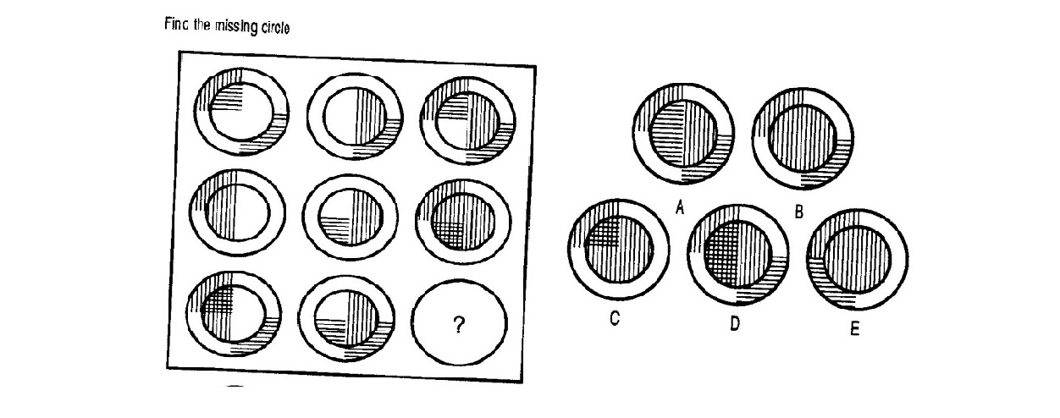Please refer Image 1 for the next question
Choose the correct option.

Q.1

A: A | B: B | C: C | D: D | E: E
Image : 2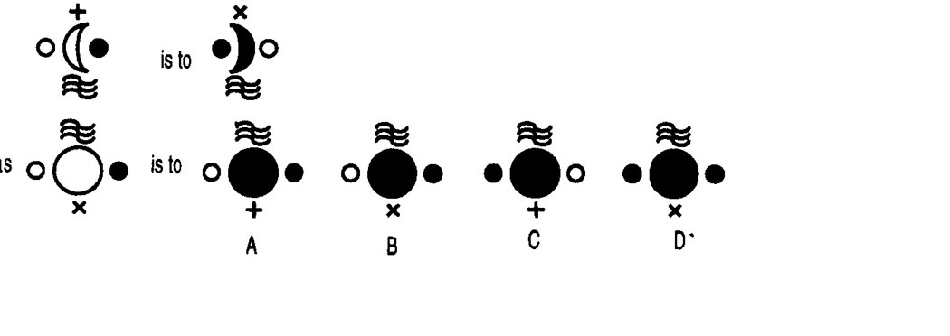Please refer Image 2 for the next question
Choose the correct option.

Q.2

A: A | B: B | C: C | D: D | E: E
Image : 3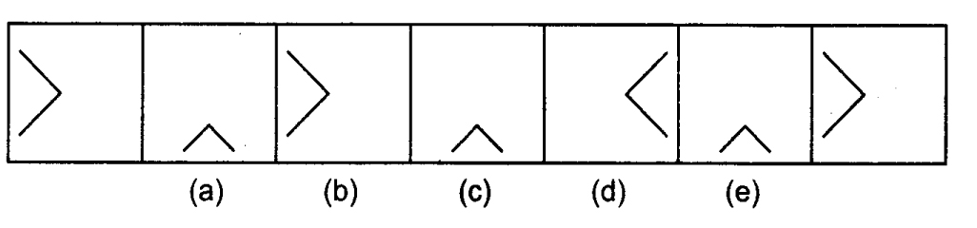Please refer Image 3 for the next question
Directions : In the following question, a series begins with unmarked figure on the extreme left. One and only one of the five marked figure does not fit into the series. The two unmarked figures, one each of the extreme left and extreme right fit into the series. You have to take as many aspects into account as possible of the figure in the series and find out the one and only one of the five marked figures which does not fit into the series. The number of that figure is your answer. Choose the correct answer.

Q.3

A: A | B: B | C: C | D: D | E: E
Image : 4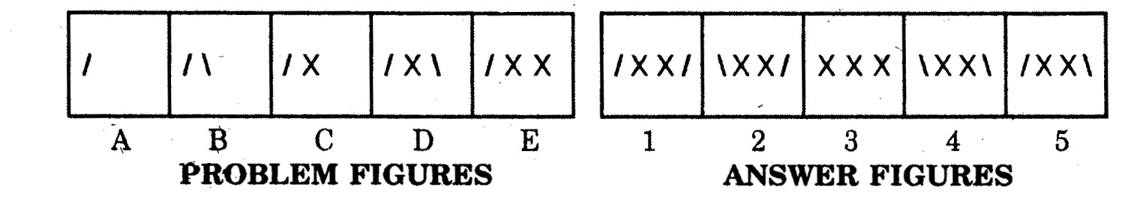Please refer Image 4 for the next question
Directions : Each of the following quetion consist of five figures marked A,B,C,D, and E called the Problem Fighures followed by five other figures marked 1,2,3,4 and 5 called the Answer Figures. Select a figure from amongst the Answer figures which will continue the same series as established by the five Problem Figures.

Q.4

A: 1 | B: 2 | C: 3 | D: 4 | E: 5
Image : 5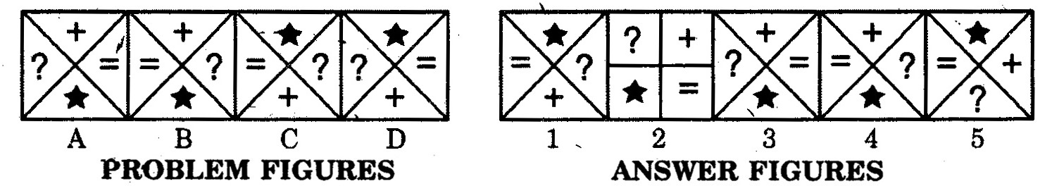Please refer Image 5 for the next question
Directions : Select a figure from the Answer set (figures 1,2,3,4,5) which would continue the series indicated by the four figures of the Problem Set (figures A,B,C,D)

Q.5

A: 1 | B: 2 | C: 3 | D: 4 | E: 5

